2023 Advanced Computer Graphics  
Final Project：Stereoscopic render and interactive scene

Student ID: M11125016 Name: Hsiao, Chiang

In this final project, I encountered several challenges as following:

1. In the previous iteration, one incomplete aspect was the lack of utilizing a normal vector to correctly rotate the plane of the taxi object along the track.
2. Make the camera chase the taxi object without happening the 90 degree rotate if the taxi object changing axis.
3. (Can’t figure out the problem) The camera will show chaotic view when changing the taxi object forward or backward.

Here’s snapshots of this final-tern project.

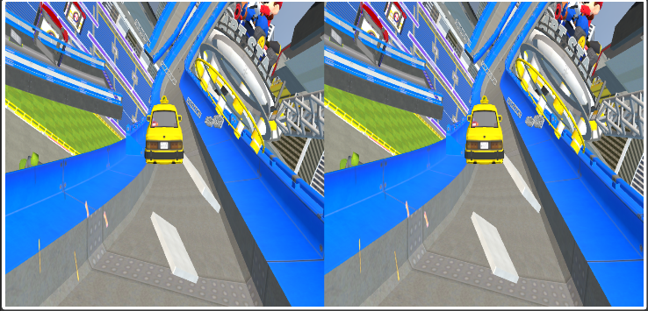

Figure 1 Stereo camera view. (default eyeSep is 0.064) Figure 2 Big picture with whole racing track with 360 backgrounds.

# Align the taxi object on the track

Continuing from the mid-term project report, I use the localToWorld function to convert coordinates from the local space of taxi object to global coordinates. Assuming the initial track direction is along the positive y-axis, I translated taxi object along the x-axis for the desired transformation. The lane center was determined by subtracting the current position of taxi object and adding the calculated track coordinates. Subsequently, I computed the distance vector between the lane center and taxi object's current position. Finally, I created a translation matrix to move taxi object along this distance vector.

In the alignment process with the track, I begin by obtaining the current orientation vector of the taxi object, which data is from the xyz file and indicates the model's upward direction. By calculating the cross product with the track's normal vector, I obtain the rotation axis (pivot). The angle between the model and the track normal vector is then determined. Utilizing the rotateOnWorldAxis function, I proceed to rotate taxi object around the calculated axis by the computed angle. This ensures proper alignment with the track.

In order to further complete the forward directionality of the taxi object, we first update alignVtr to align with the global coordinates relative to forwardDirection. When maintaining the forward and backward movement of an object, ensuring the directionality along the y-axis suffices to preserve the correct orientation throughout the iteration.

const forwardDirection = new THREE.Vector3();

if (this.direction === 1){

forwardDirection.set(0, -1, 0)  // when direction is forward

}else{

forwardDirection.set(0, 1, 0)  // when direction is backward

}

Subsequently, I recalculate the rotation axis and determine a new rotation angle. Leveraging the rotateOnWorldAxis function once more, I execute an additional rotation around the updated axis by the new angle. This step ensures a more precise alignment in accordance with the updated parameters.

# Make the camera chasing the taxi object

The camera is configured similarly using the localToWorld method to consistently position it at specific coordinates relative to the taxi object. Subsequently, the camera is directed to looking at the taxi object using the lookAt method. However, a challenge arises when the taxi object rotates along different axes, causing the camera to rotate either left or right by 90 degrees. To address this issue and ensure a consistent upward direction, an upVector is generated within the local coordinate system of the taxi object by converting the vector (0, -1, 0) to the global coordinate system and normalizing it.

# Conclusion

This challenging assignment took me eight days to complete, providing a thorough exploration of the application of 4x4 matrices in computer graphics. It involved operations such as translation, rotation, and the use of normal vectors to control surfaces in three-dimensional space. As someone who hadn't dealt with linear algebra in nearly a decade, it posed a significant challenge. Fortunately, I overcame this obstacle by promptly supplementing the provided materials with additional resources, watching online tutorials, and engaging in collaborative learning with classmates. This collective effort alloId us to successfully navigate through the semester together.